Working with Numeric Data Types

## **Accessing the AWS Cloud9 IDE**

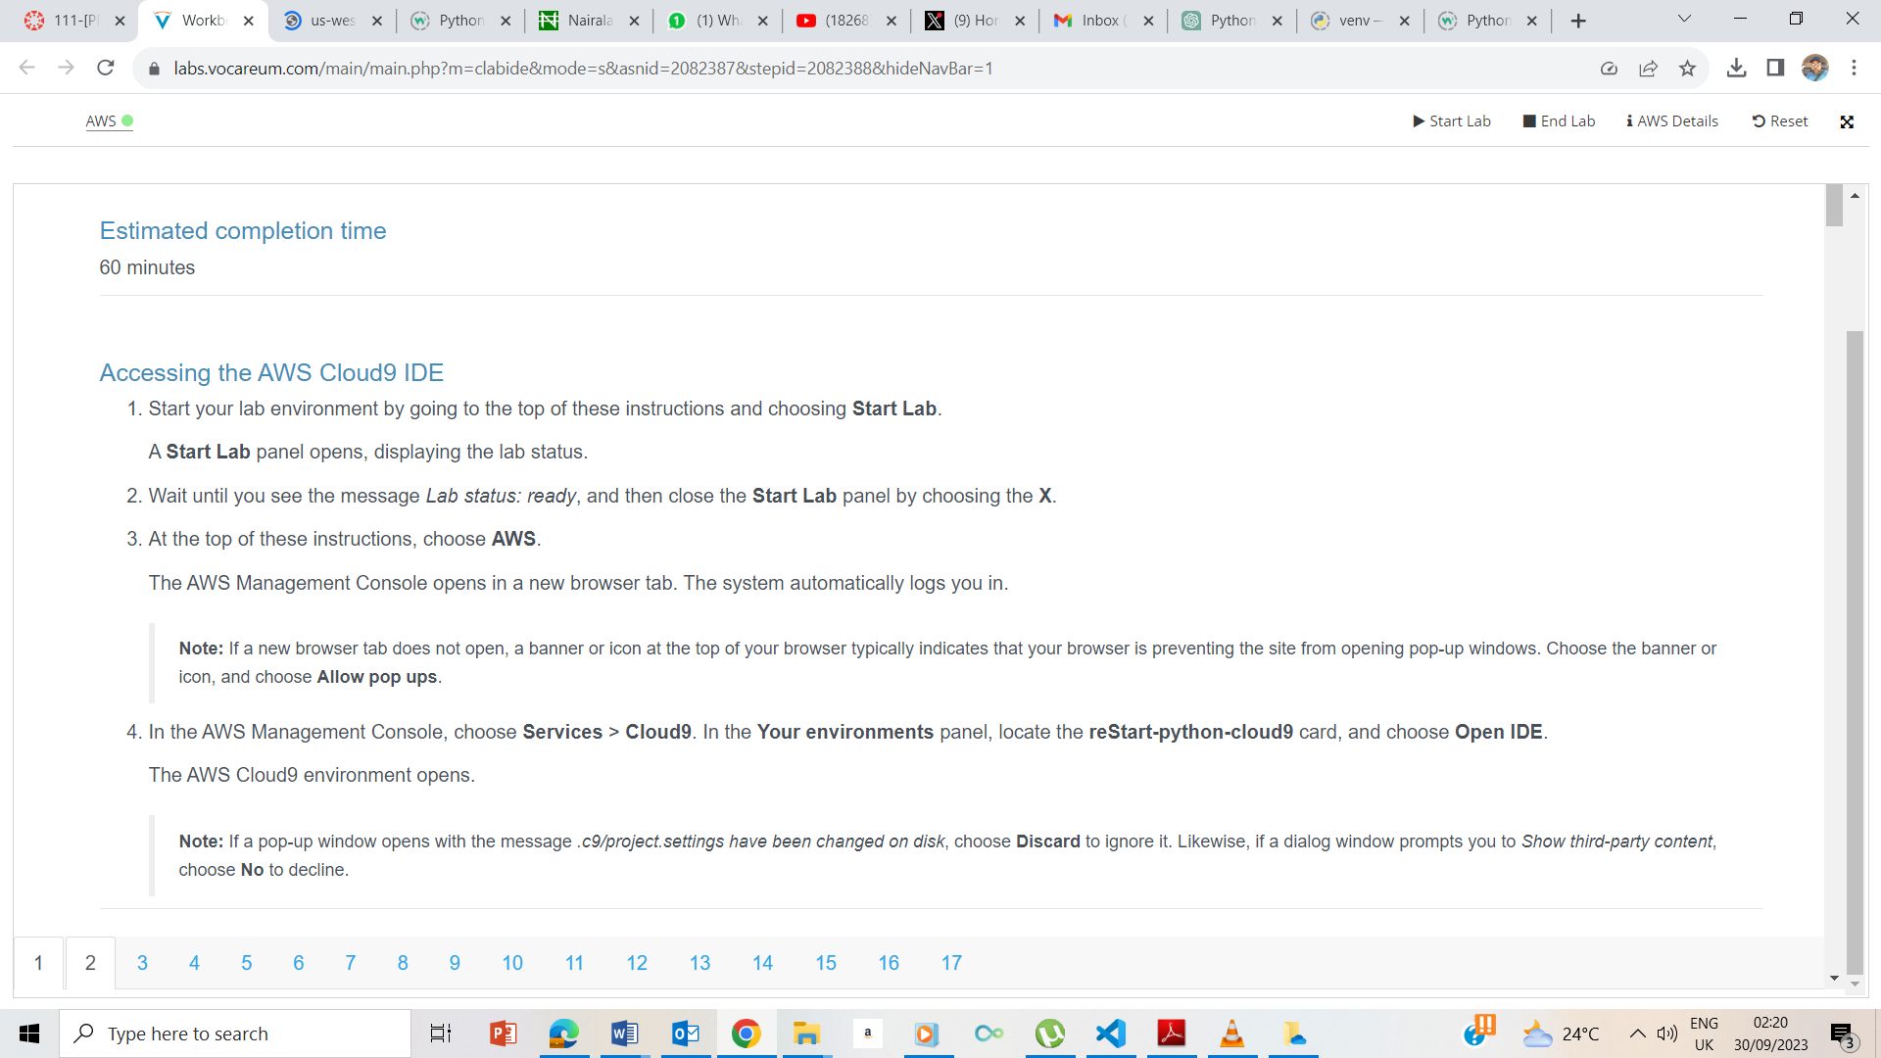

Lab console ready

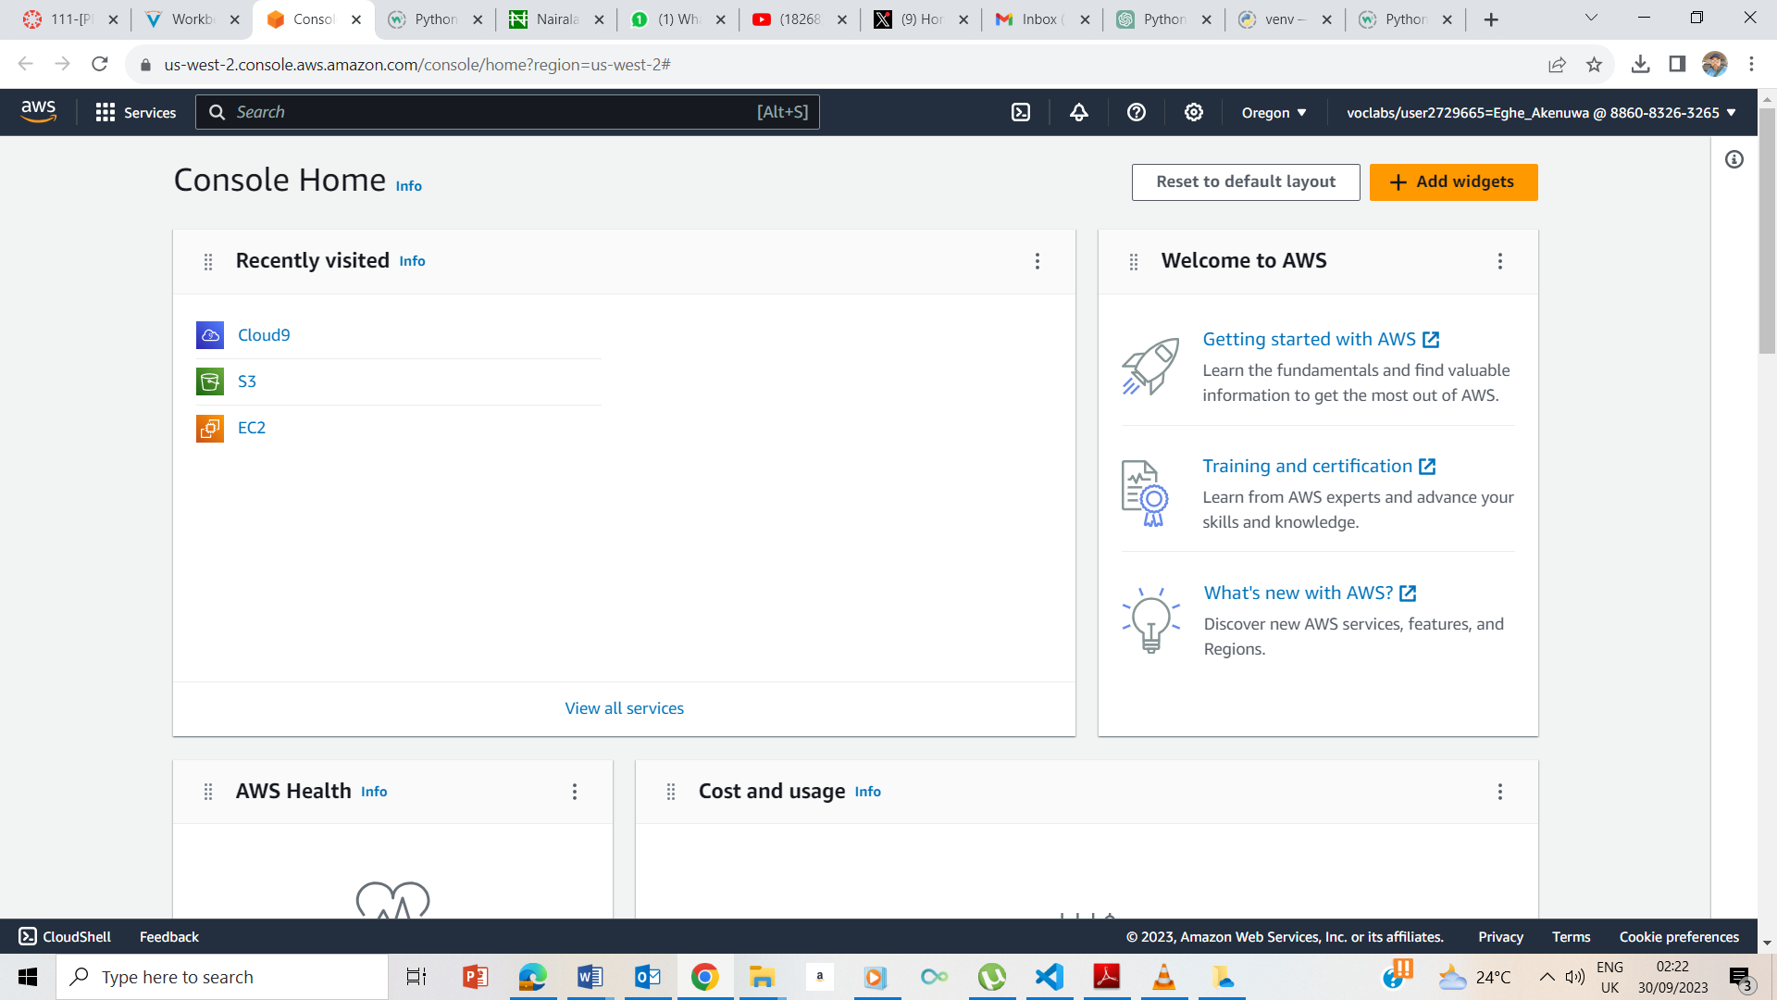

I clicked on the AWS button to take me to the AWS management console page

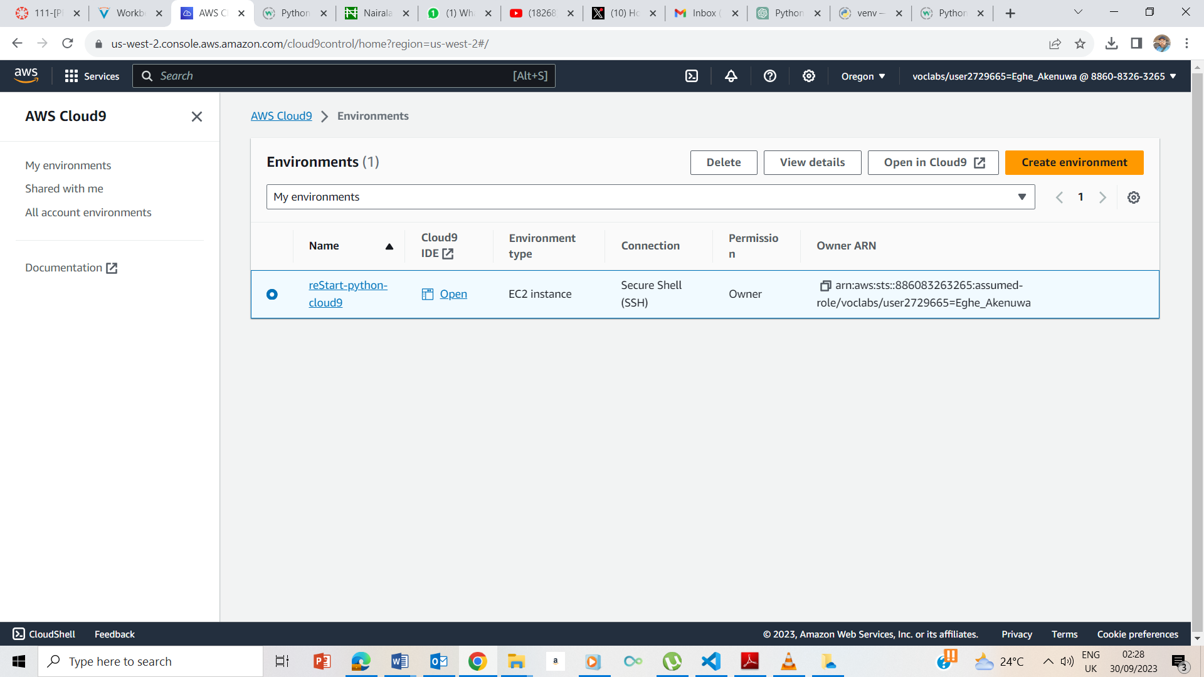

I clicked on the Cloud9 and took me to the page above

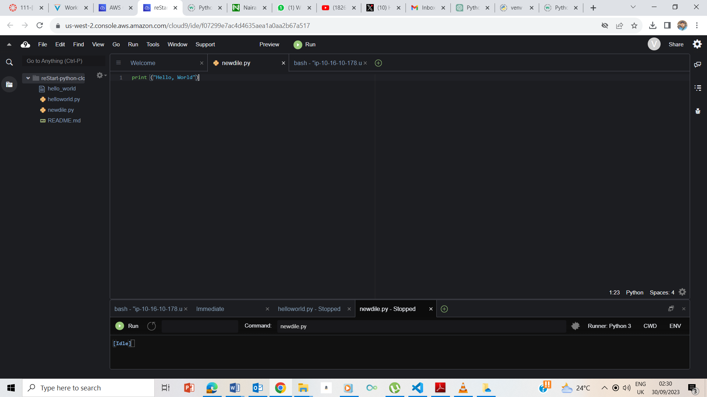#

I clicked on the Open IDE and it took me to the Amazon Cloud9 environment

## **Creating your Python exercise file**

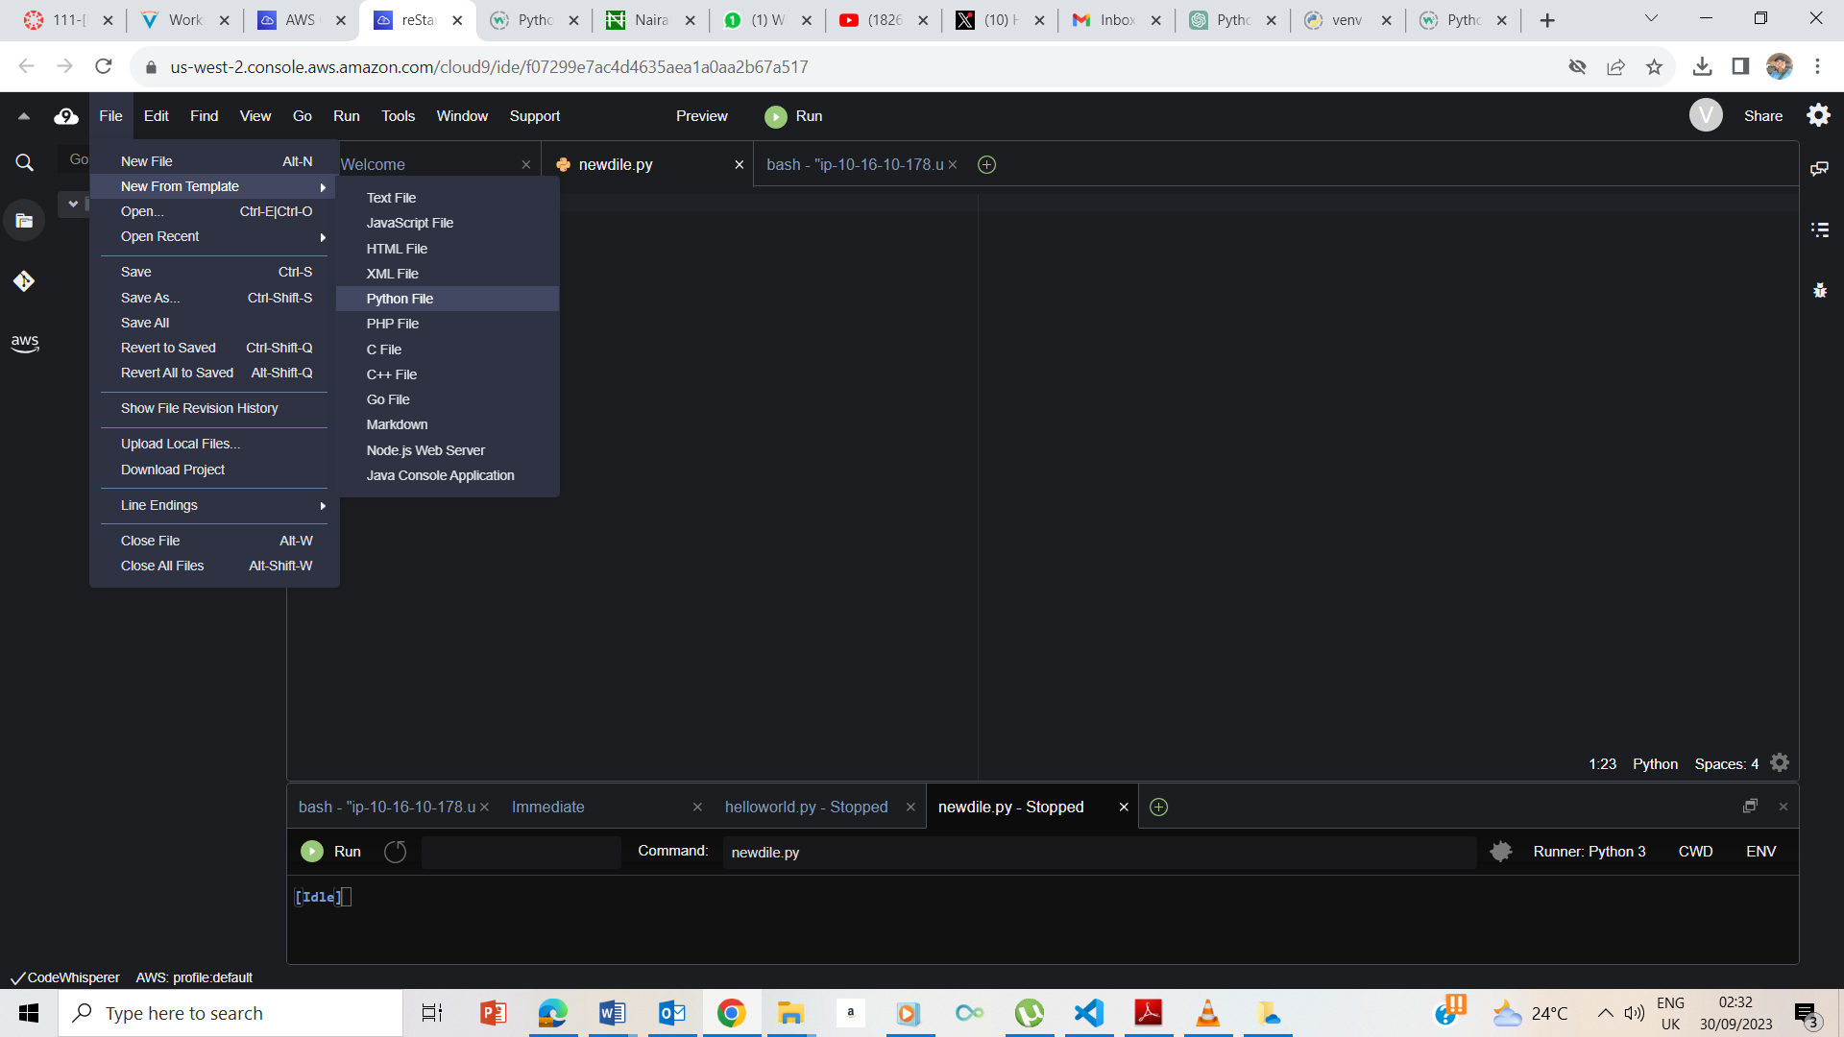

I clicked on File ->New file from Template -> Python File

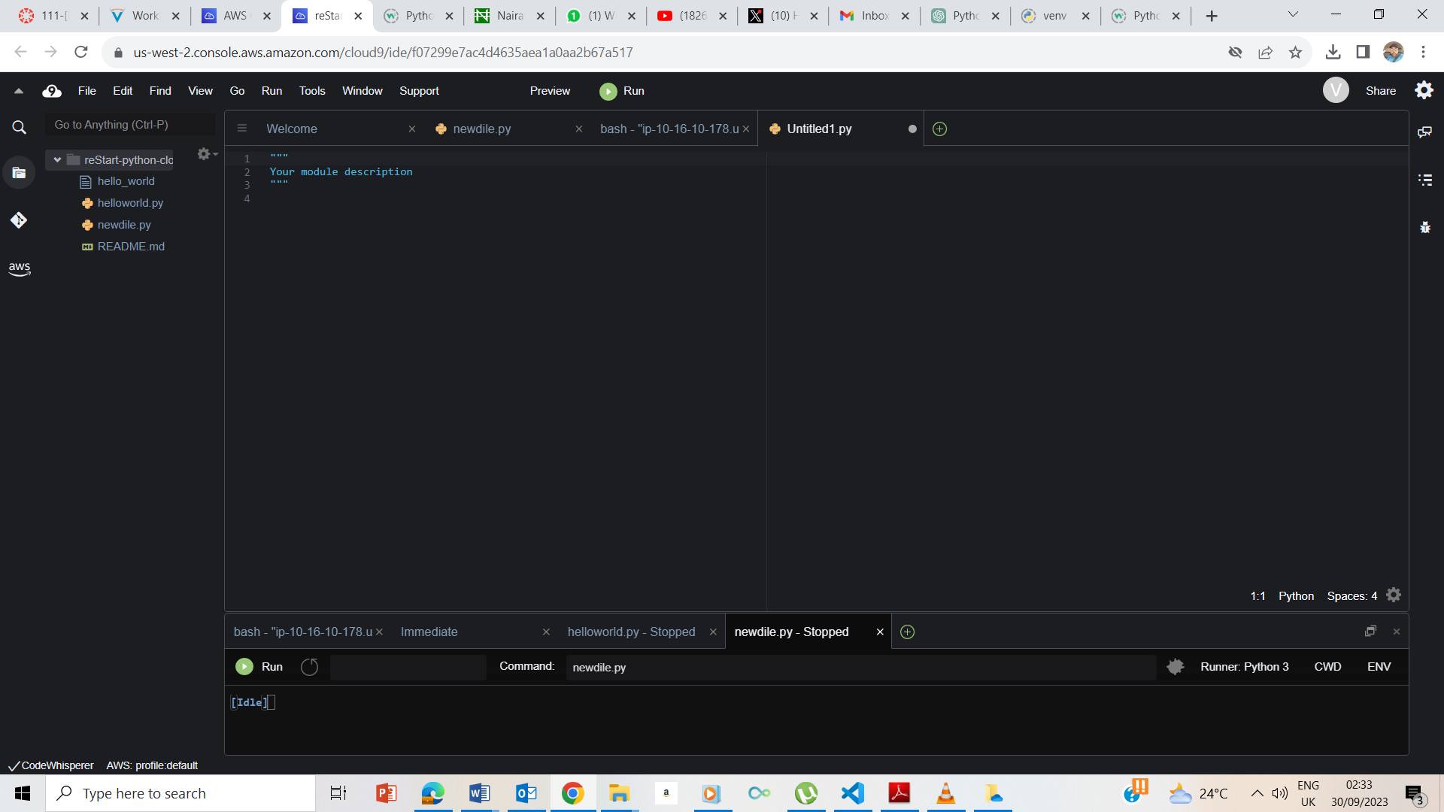

The New File Template. I deleted the items on the file.

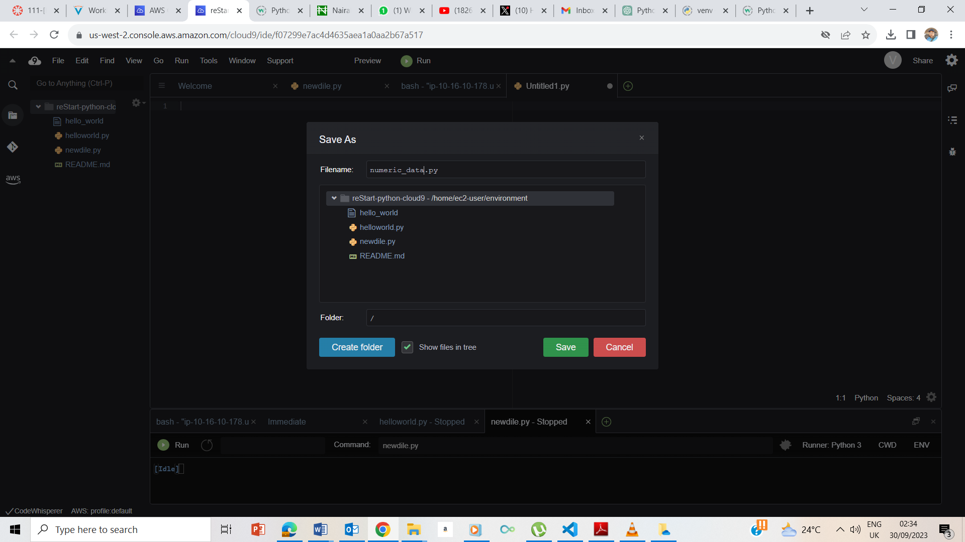

I saved the file as numeric_data.py

## **Accessing the terminal session**

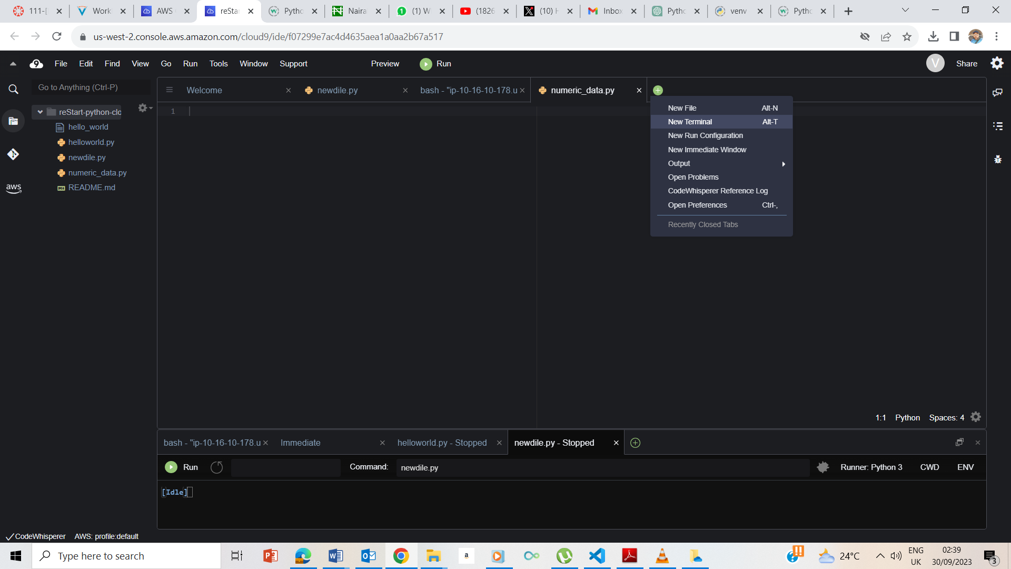

I clicked on the + sign to take me to a new Terminal

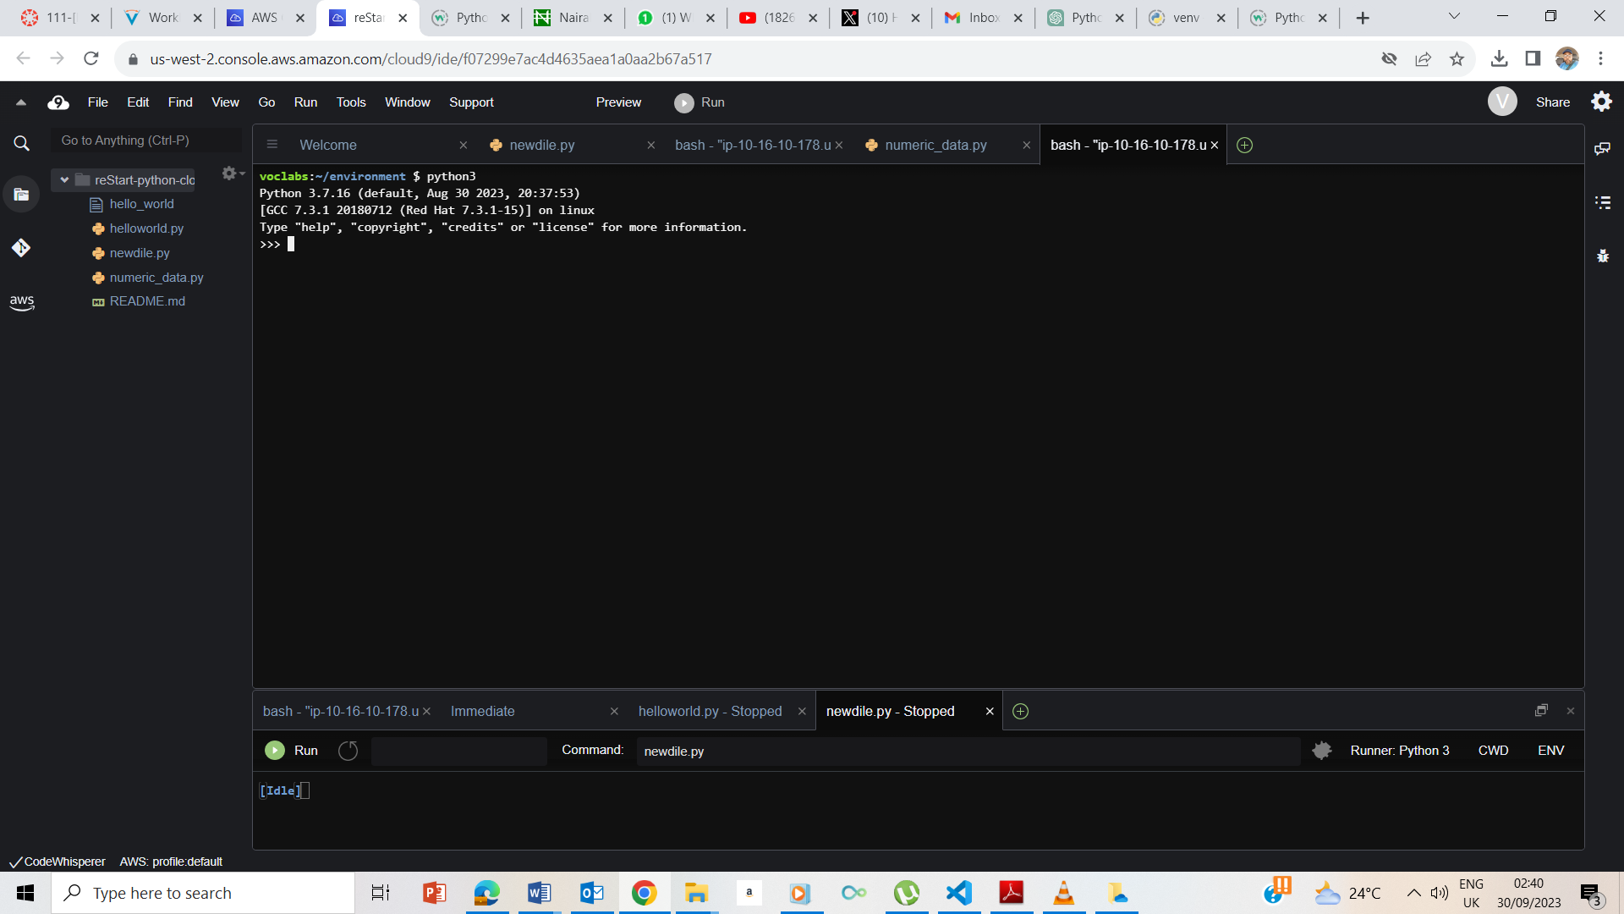

I entered python3 and entered.

### **Adding**

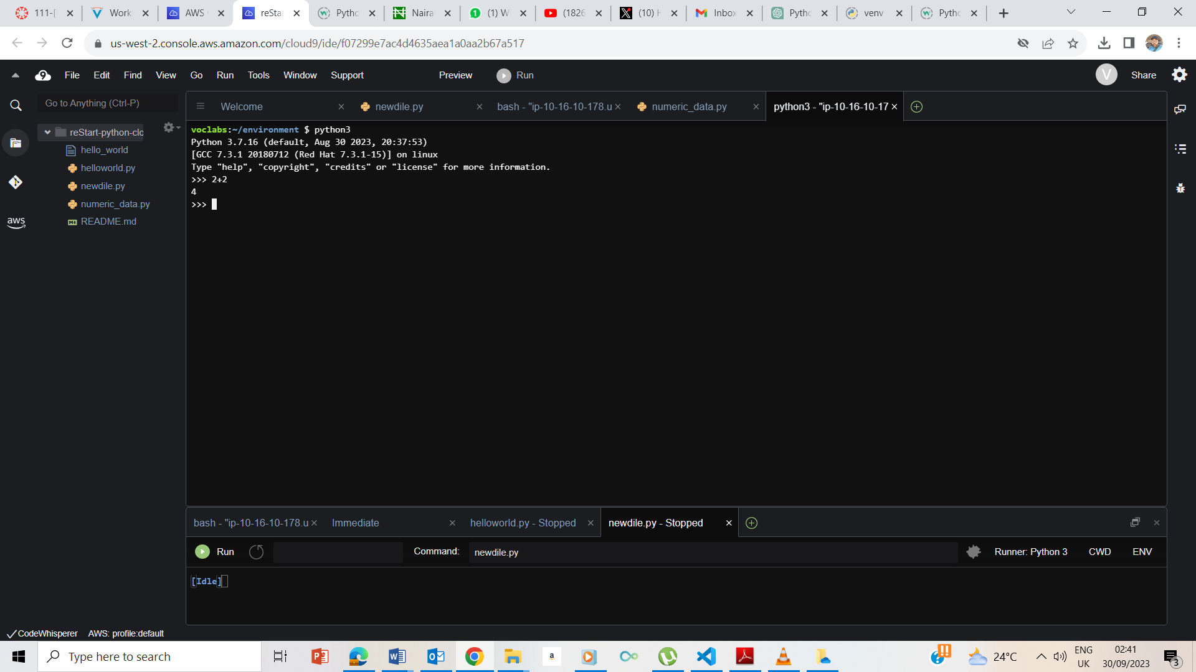

I entered 2+2 and got the output as 4

### **Subtracting**

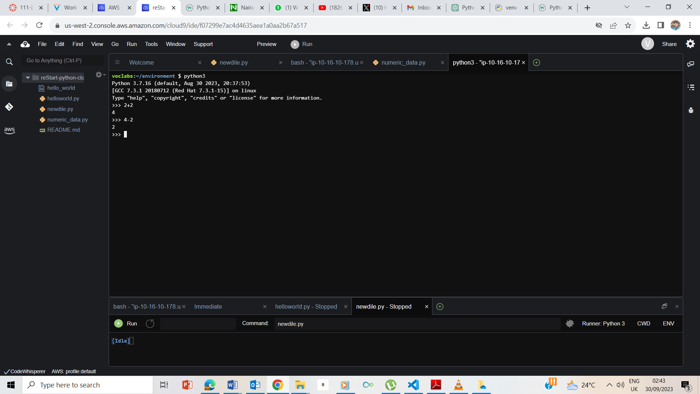

I entered 4-2 and got 2 as the output.

### **Multiplying**

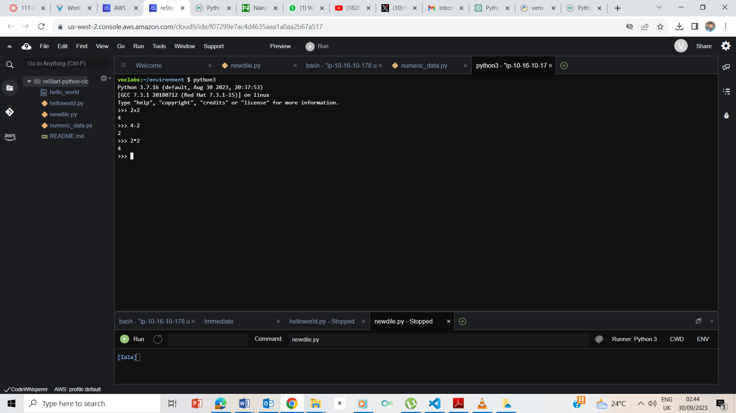

I entered 2*2 and got 4 as the output

### **Dividing**

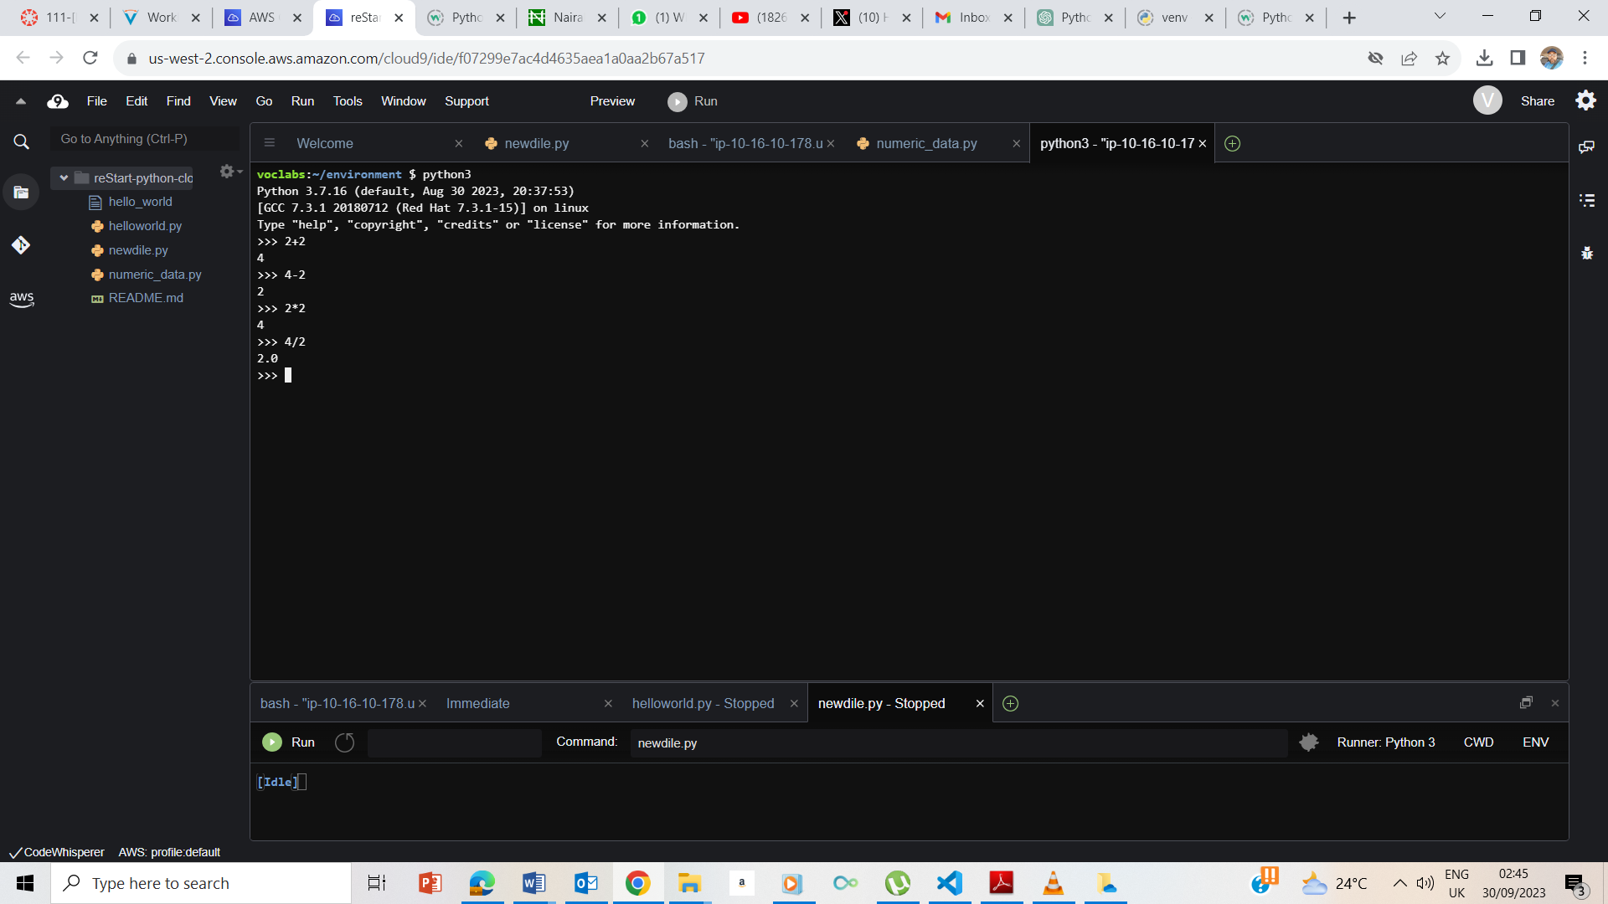

I entered 4/2 and got 2.0 as the output

### **Exiting the Python shell**

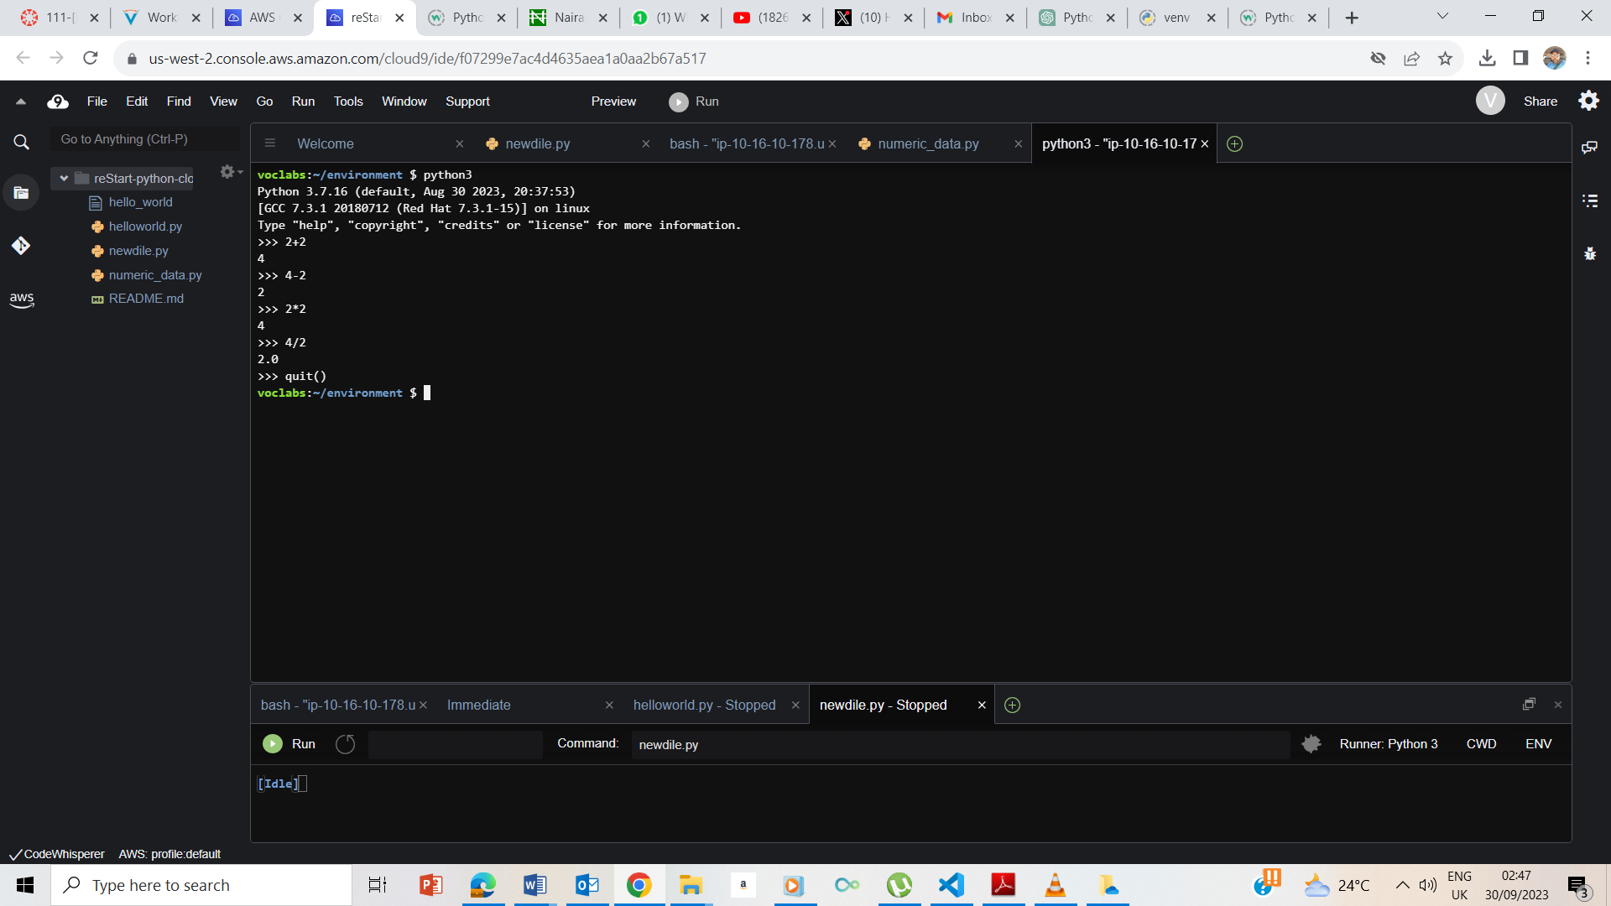

I entered quit() and exited

## **Exercise 2: Introducing the int data type**

### **Editing a Python file**

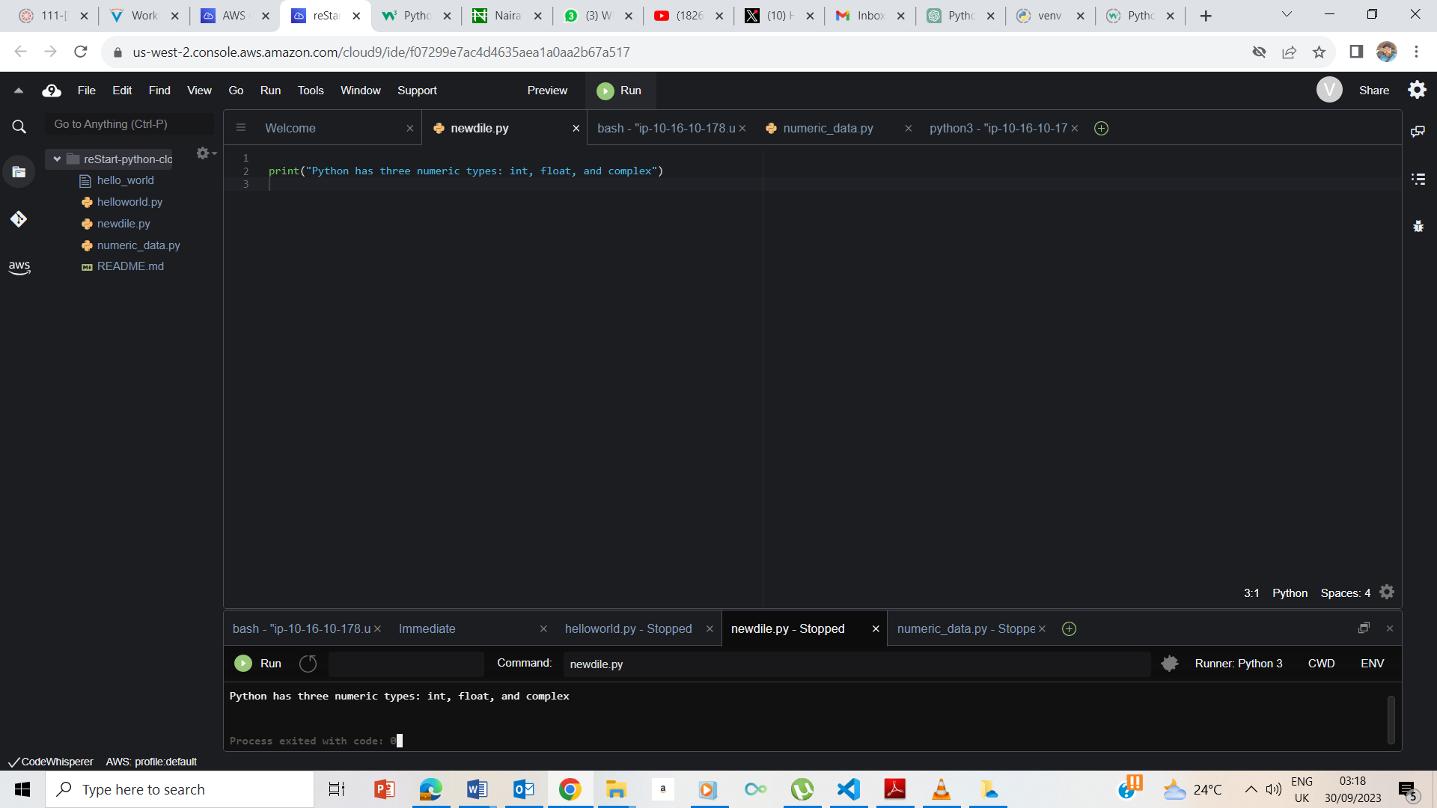

I typed Print(“python has three numeric types: int, float , and complex’) ran it and it output same

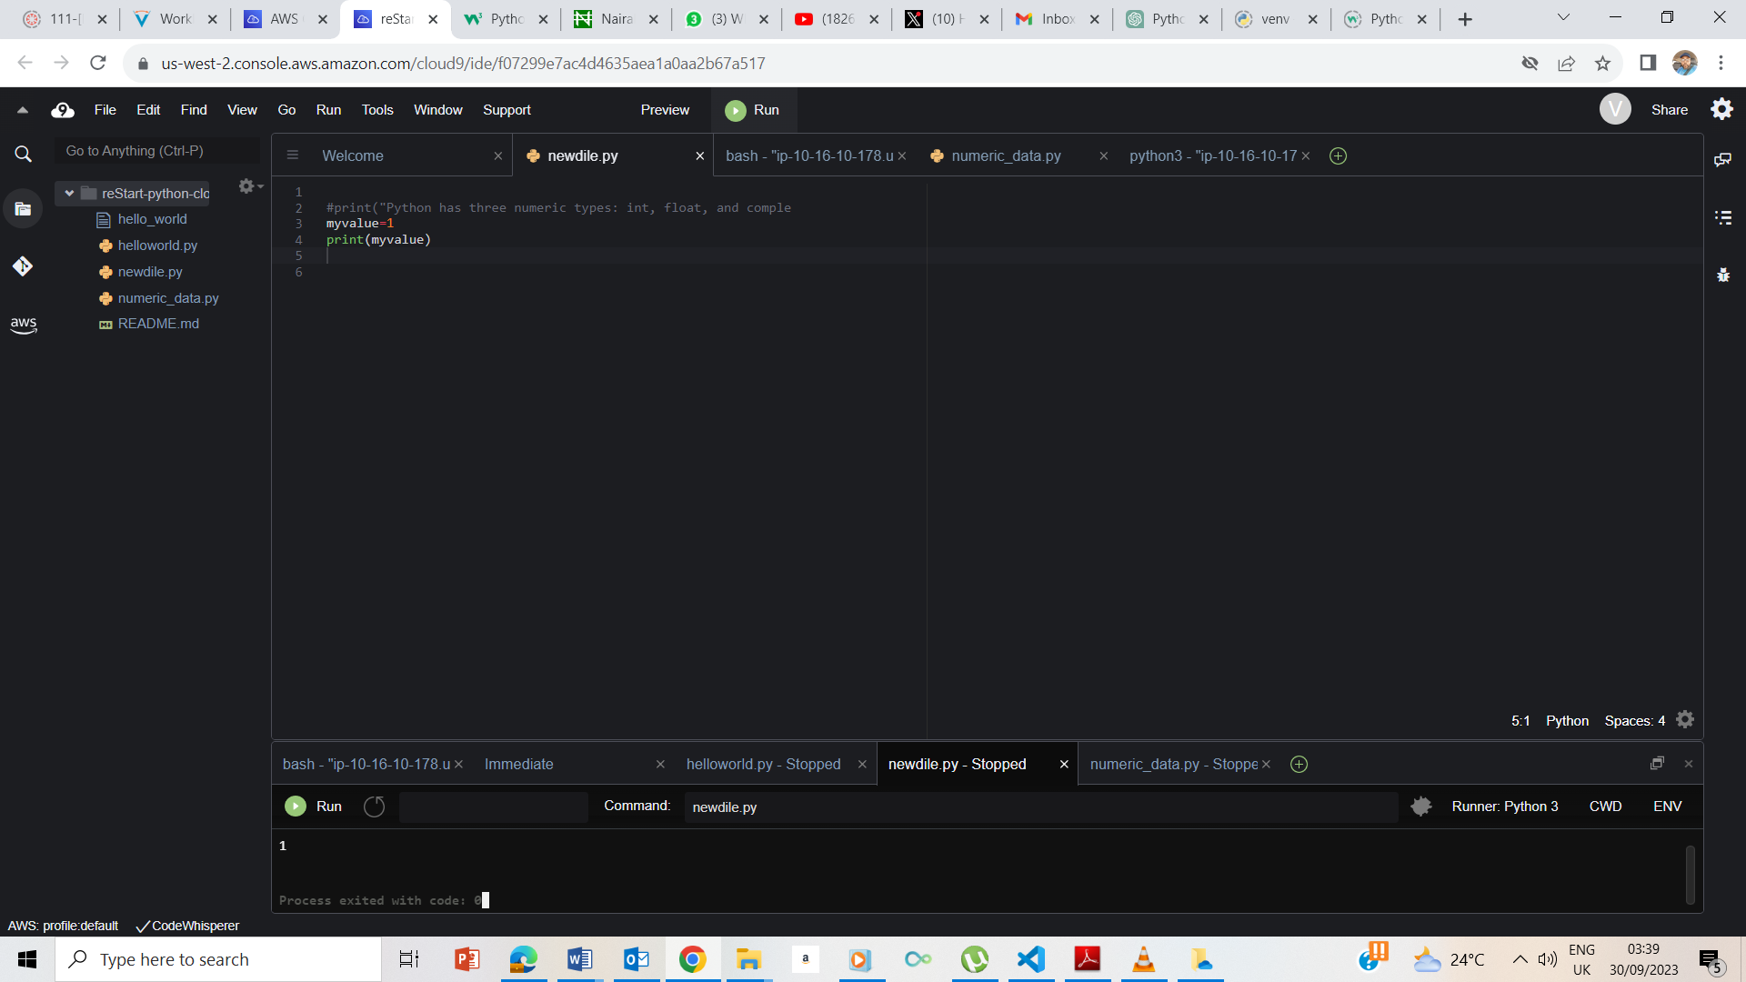

I ran the code, myvlue=1 ; print(myvalue) and the output was 1

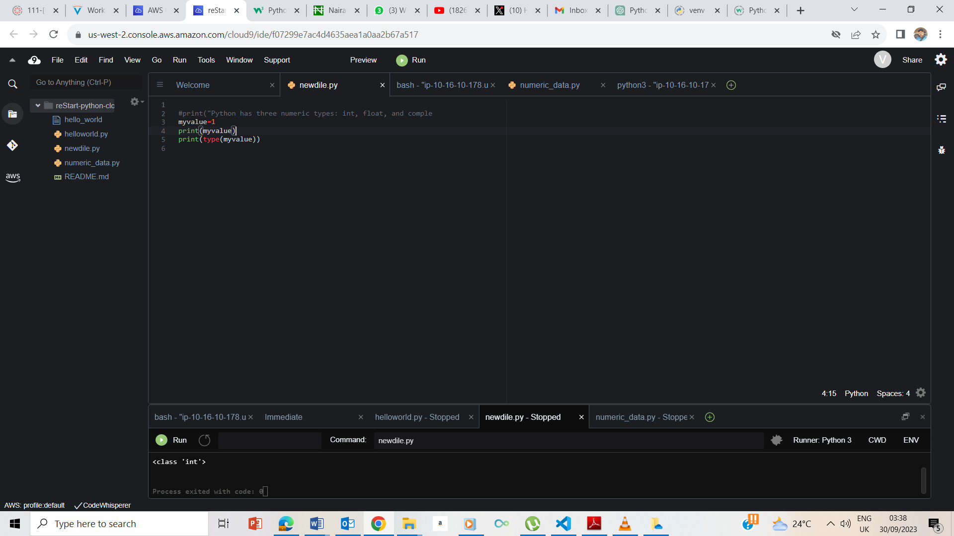

I also entered the code print(type(myvalue)) and the output was int ie integer

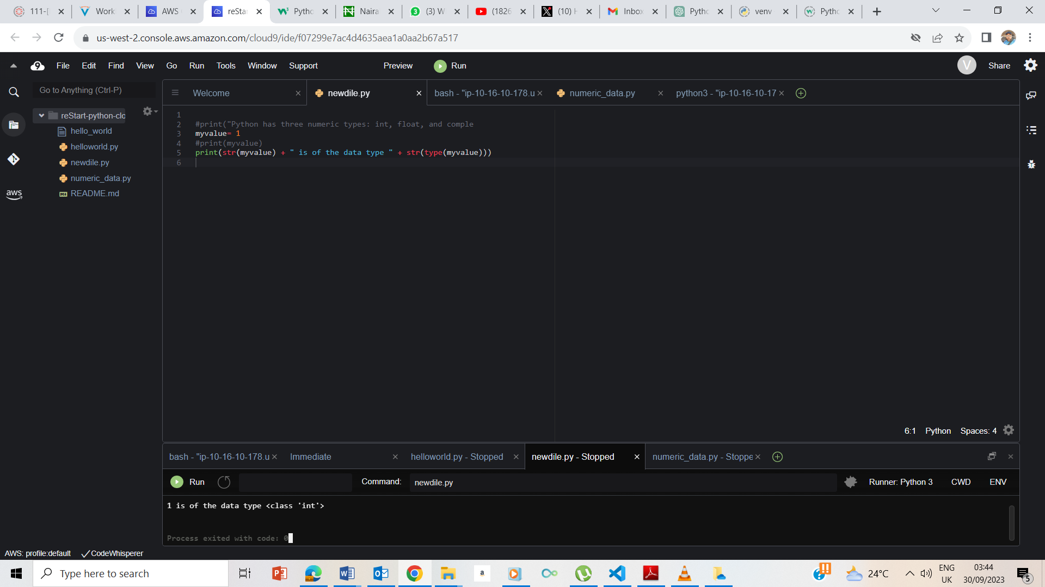.

## **Exercise 3: Introducing the float data type**

I entered myvalue= 3.14 and print(myvalue) and the output was 3.14

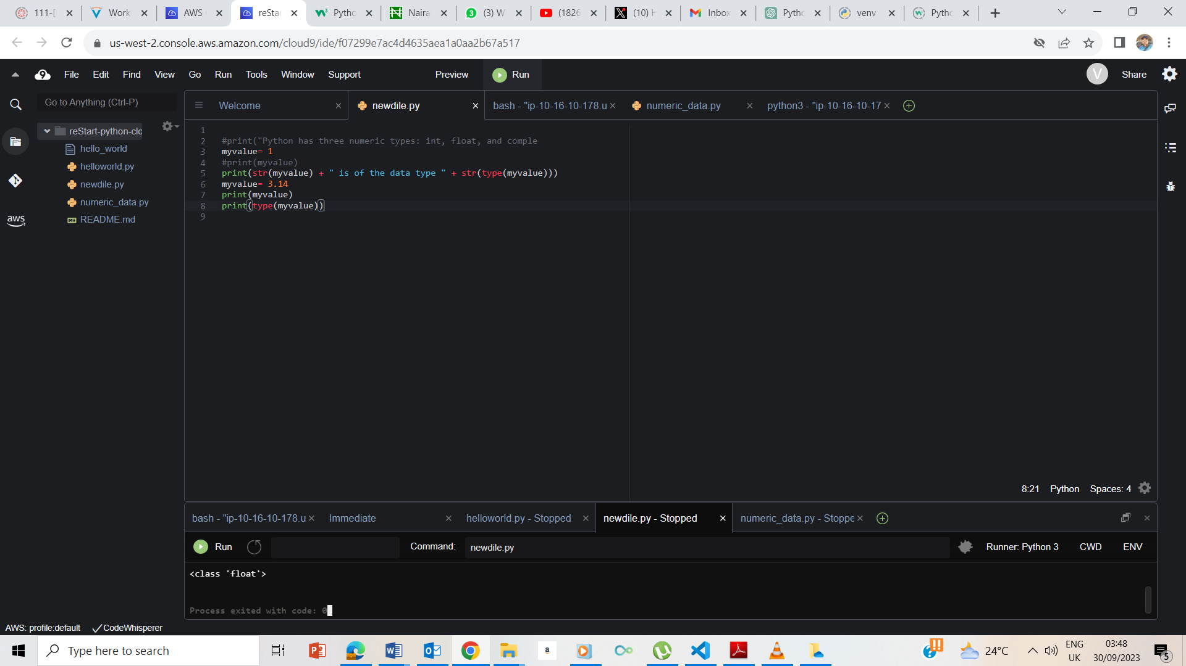

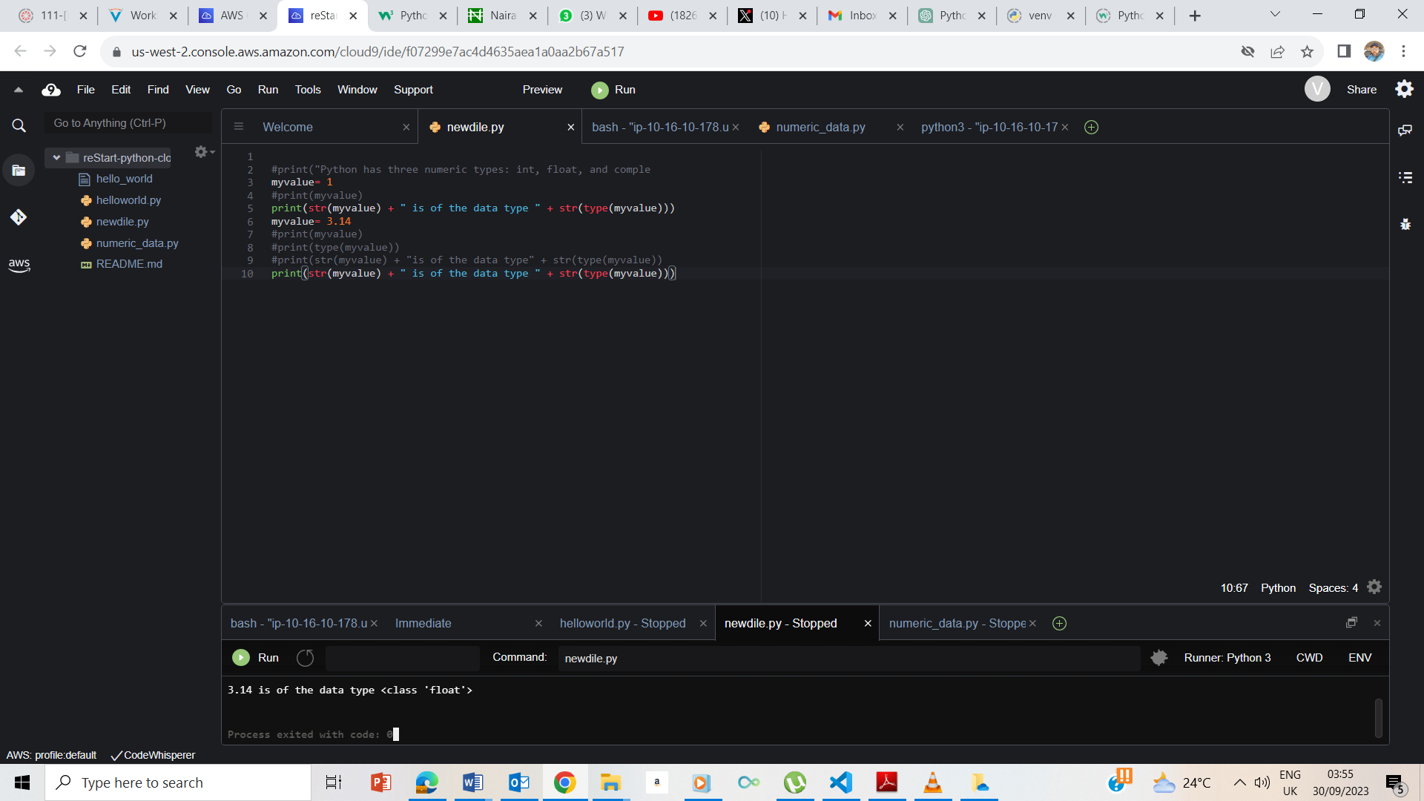

3.14 is of class float.

## **Exercise 4: Introducing the complex data type**

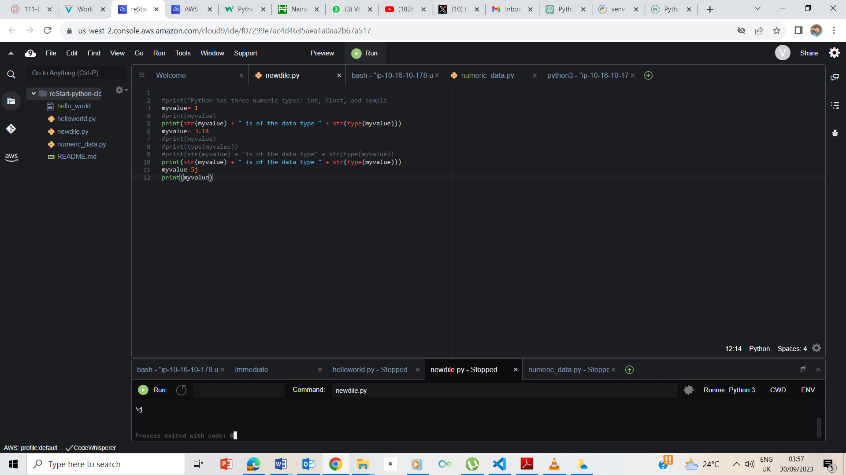

My value=5j

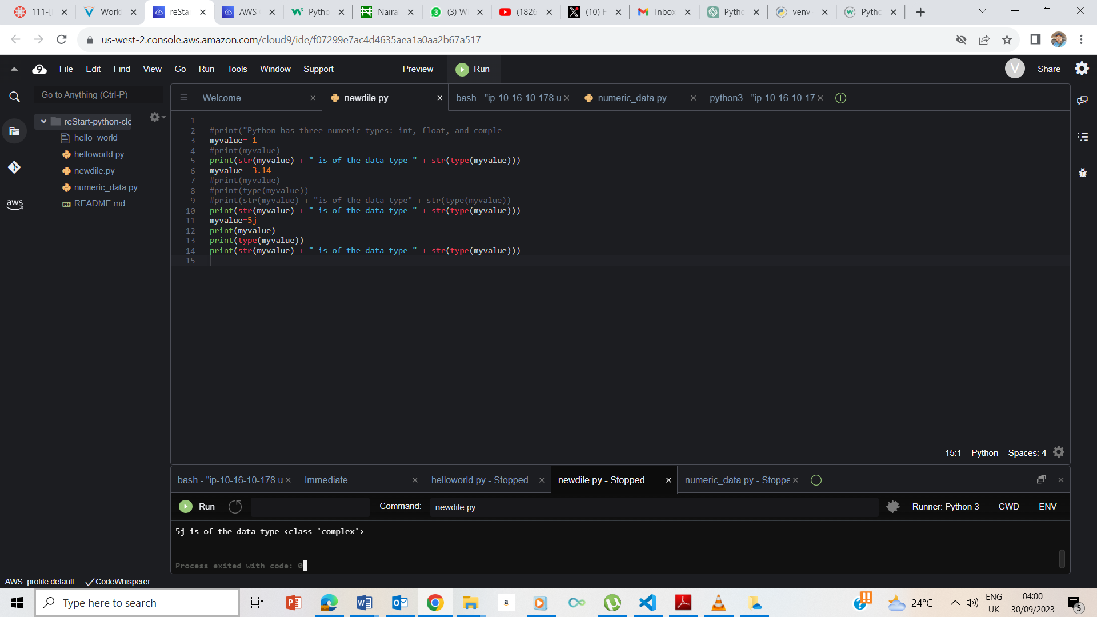

The number 5j is of a complex type

## **Exercise 5: Introducing the bool data type**

Myvaue= True

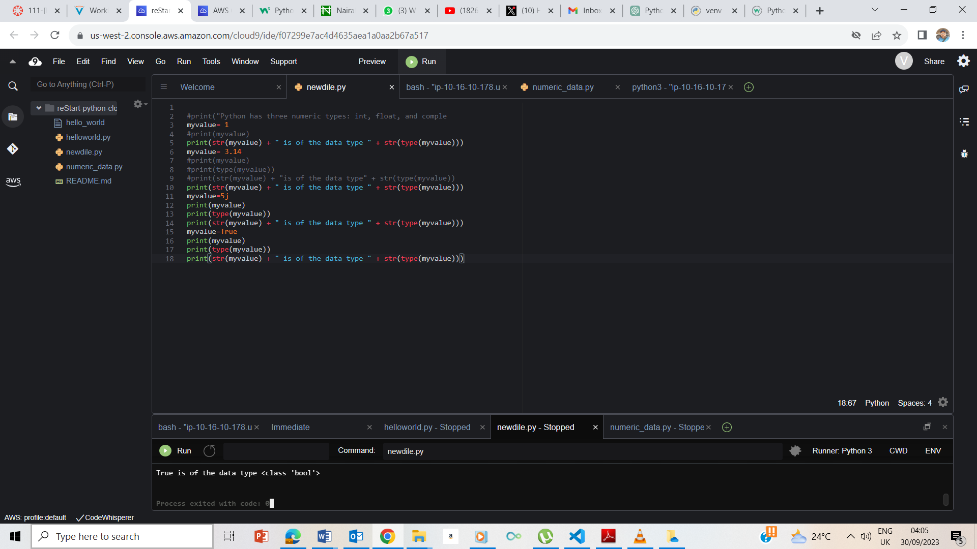

True is of a Boolean type

## **End Lab**